SUSE Enterprise Storage Deployment Guide for Veritas NetBackup Using S3

December 2017

Kian Chye Tan

**Executive Summary**

SUSE Enterprise Storage(SES) delivers software-defined storage (SDS) that provides the comparative functionality of mid- and high-end proprietary storage arrays at a fraction of the cost and with far more flexible operational scalability. Truly unlimited scalability enables enterprise IT organizations to deliver the agility business demands by adding capacity without disrupting business, at costs they want to pay.

With SUSE Enterprise Storage, users can benefit from the low cost-effective storage and highly scalable storage. This is suitable for use as a backup/archival target in the real world where enterprise customers are struggling with expensive, proprietary solutions that lack scalability.

**Introduction**

This document provides basic instructions for setting up the SUSE Enterprise Storage S3/Object Storage Interface with VERITAS NetBackup. This document assume the reader has some level of understanding with SUSE Enterprise Storage and is focusing on setting VERITAS NetBackup interface with SUSE Enterprise Storage. Users who are familiar with VERITAS NetBackup should be able to proceed as usual after setting up for use with SUSE Enterprise Storage (SES). For more information, please refer to the VERITAS NetBackup Administration and the SUSE Enterprise Storage (SES) Administration documentation.

**Target Audience**

System Administrators and Vendors associated with performing deployments are encouragd to use this document to take advantage of real-world knowledge gained by SUSE employees who have performed this work at actual customer enviornments.

**SUSE Enterprise Storage**

A SUSE Enterprise Storage solution is:

Simple to setup and deploy, within the documented guidelines of system hardware, networking and environmental prerequisites.

Adaptable to the physical and logical constraints needed by the business, both initially and as needed over time for performance, security, and scalability concerns.

Resilient to changes in physical infrastructure components, caused by failure or required maintenance.

Capable of providing optimized object, block, and file services to client access nodes, either directly or through gateway services.

Able to have data protection configured to meet the customer's individual needs at a granular level

**VERITAS NetBackup Background**

VERITAS NetBackup (NBU) has the largest market share for Enterprise Backup. Most hardware and software vendors test and certify their products with NBU.

Recently, with the adaption of cloud in the commercial space, Veritas launched a series of product updates which also include cloud integration features with Amazon and Microsoft Cloud. To support these public clouds, the NetBackup software uses the industry standard Amazon S3 interface. The S3 protocol is well supported with SUSE Enterprise Storage and easily deployable. This document will describe the process to setup Veritas NetBackup with SUSE Enterprise Storage using the Amazon S3 protocol.

The software used in this documentation are as follow:

SUSE Enterprise Storage 4 or greater

VERITAS NetBackup 7.7.3 and above

**Deploy & Prepare SUSE Enterprise Storage**

SUSE Enterprise Storage should be deployed as described in the deployment guide[1]1 with roles for the Object Gateways (RGW) assigned and deployed during stage 4.

After the cluster is up and operational, an S3 user must be created for use with VERITAS NetBackup. This can be done via CLI or GUI (from SESv5 onwards).

Create S3 User

Login to the RADOSGW node via SSH, and create an S3 user. Below shows an example creating a user named ‘s3user’. Note the field “access key” and “secret key” from the results return. These two pieces of information are needed during the stage when configuring VERITAS NetBackup to connect to SUSE Enterprise Storage.

|  |
| --- |
| **node54:~ # *radosgw-admin user create --uid=s3user -–display-name = ”S3 User****”*  ***node54:~ # radosgw-admin user info --uid=s3user***  {  "user_id": "s3user",  …..  {  "user": "s3user",  "access_key": "**E9I6QYS53HOOODVUO07M**",  "secret_key": "**x6cz1Jy5oxRBDyUunlHABMXbmS8FSDEmJndvhtef**  **….**  **}** |

For SES version 5 and above, you have the option to create the user from Openattic GUI interface. After logging into Openattic, click on **Object Gateway**, followed by **User**.

In the subsequent page, click **Add**.

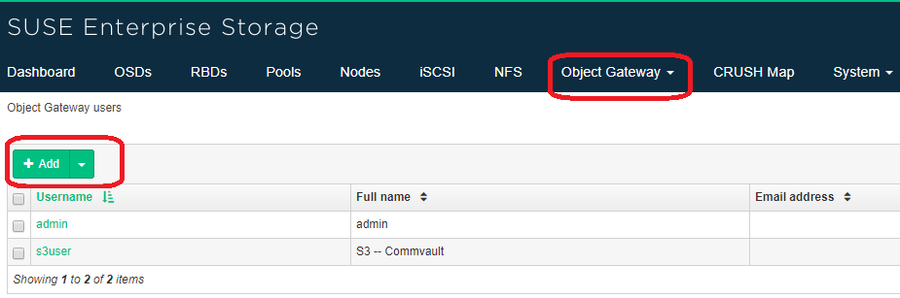

In the user creation page, enter the Username & Full Name. Ensure that **Generate Key** is checked and click submit.

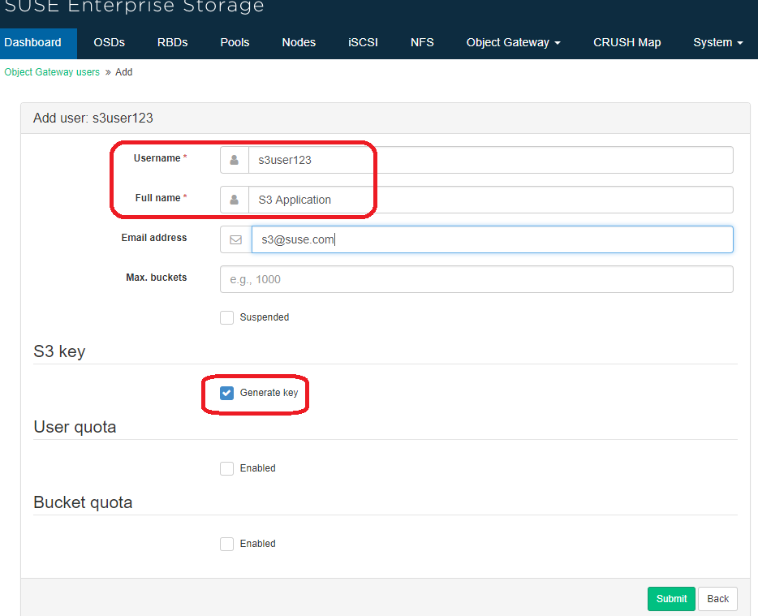

At the final stage, go back to list all the User for Object storage. Click on the username that you have created. View the Keys of the user. You will need both the **Access Key** and **Secret Key**. Click on to view the actual key.

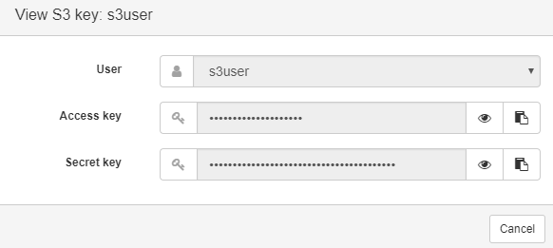

**Deploy VERITAS NetBackup System**

To deploy VERITAS NetBackup, perform the following steps:

Setup VERITAS NetBackup Master Server

This deployment example is on a Windows-based platform. To install VERITAS NetBackup Master Server, double click on Setup and follow the wizard.

1. 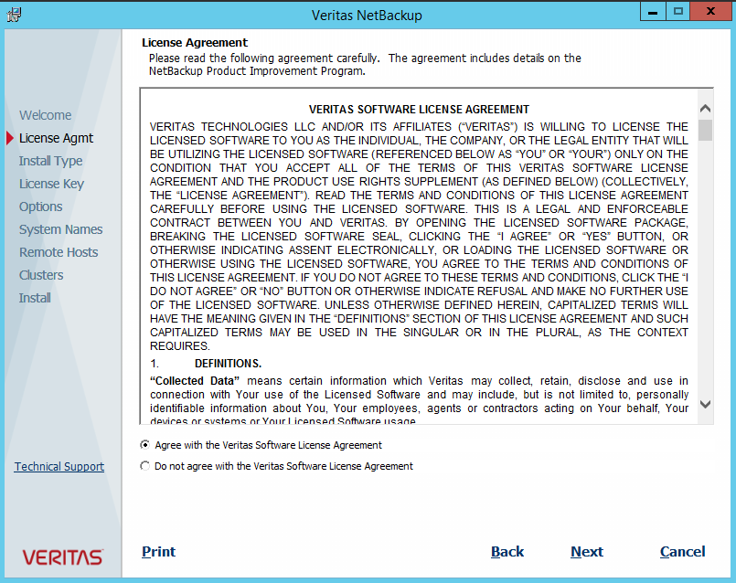Select **Agree with VERITAS software license agreement** and click **Next**.
2. Under Install Type, choose **Install to this computer only** for local installation and select "Typical Installation" which uses default settings. To continue, click **Next**.

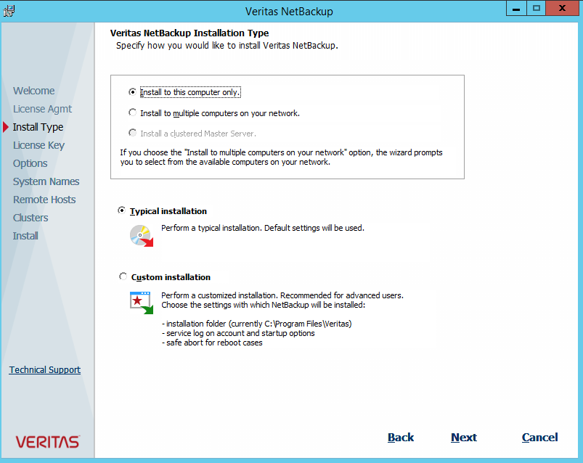

1. 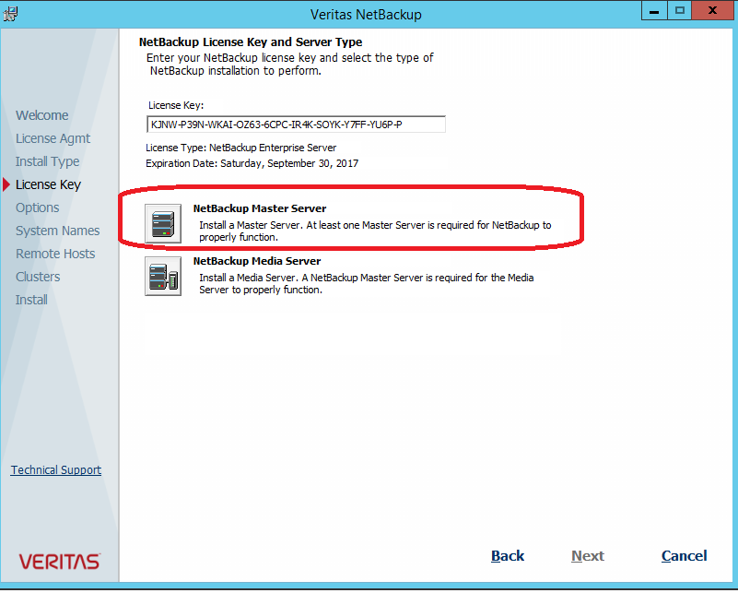Select **NetBackup Master Server** and provide the license key.
2. A summary of selected settings will be listed. Confirm that these are the correct settings and click **Install** to proceed with installation. Follow the wizard until complete.

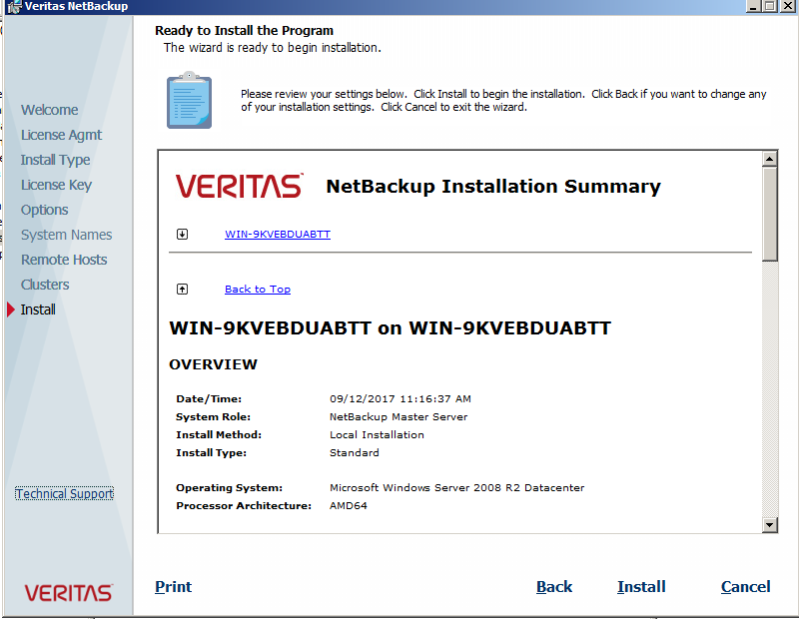

Setup VERITAS NetBackup Media Server

After installing the NetBackup Master Server, the next component to install is the NetBackup Media Server. Depending on your requirements, you can install one or multiple media servers. For this setup, follow the steps below to install a single NetBackup Media Server.

1. Accept the NetBackup Software license agreement and click **Next**.
2. For Install Type, select **Install to this computer only** for local install and **Typical Installation** to use default settings during install.
3. Provide the NetBackup License Key and select **NetBackup Media Server**.
4. Fill out the Master Server Name to which this media server will be associated. Click **Next** to install and follow the wizard until complete.

**Deploy VERITAS NetBackup Cloud Connector**

To deploy VERITAS NetBackup Cloud Connector, perform the following steps.

Netbackup Master Server Version

SUSE Enterprise Storage is available as a backup target for Netbackup version 7.7.3 onwards. If you are installing on Netbackup 7.7.x, you will need to install additional ETrack 3881336. Contact VERITAS Support for download for this ETrack

If you are going to install NetBackup version 8.x, you can start using NetBackup to SUSE Enterprise Storage (SES).

Configure Cloud Storage Server

To set up VERITAS NetBackup Cloud Storage Server, perform the following steps.

1. Using NetBackup Administration Console, select Master Server on the left pane. Choose **Configure Cloud Storage Server** on the right pane.

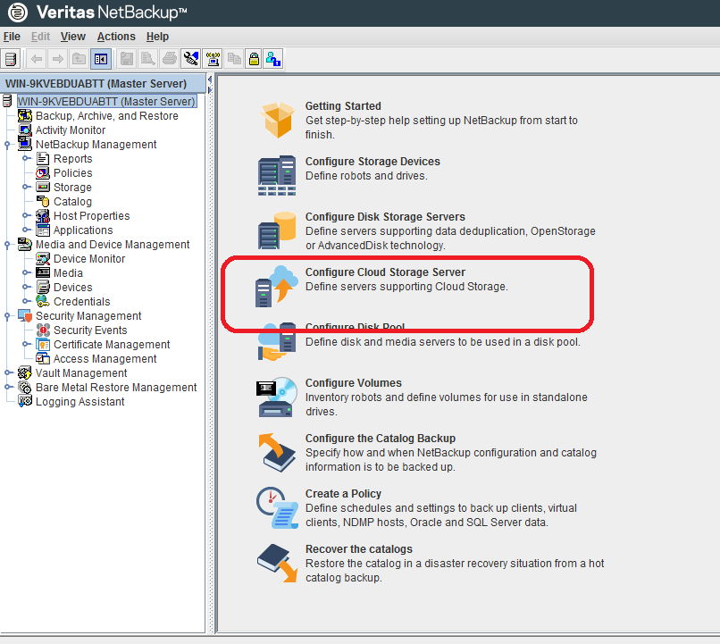

1. Select your provider in the list of Cloud Storage Providers:

* Select Storage API Type as **Amazon S3**
* If you are deploying with off premise **SUSE Enterprise,** select any of the S3 compatible S3 Cloud Provider.
* Click **Next**

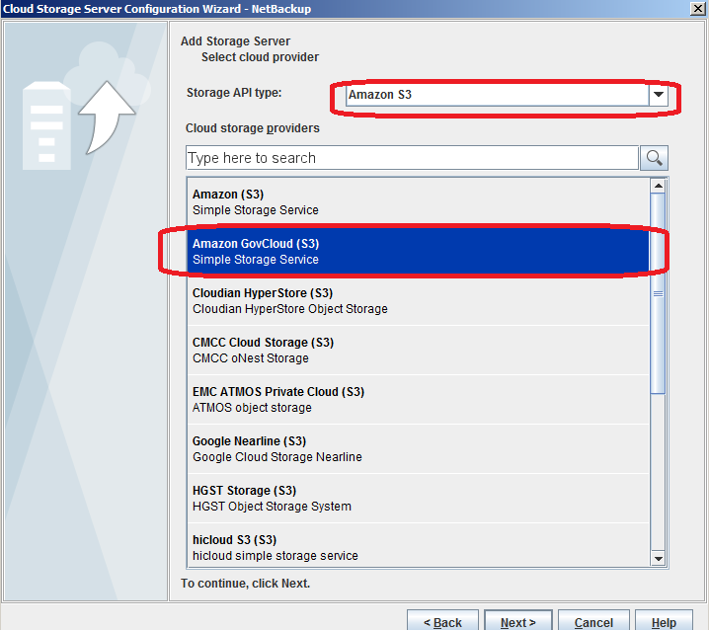



**NOTE** – At this point of writing this document, NBU version 8 has no S3-Compatiable Cloud Provider listed that is suitable for SUSE Enterprise Storage.



1. In the Cloud Storage Provider section on the following page click **Add Cloud Storage**
2. In the **General Settings** tab of the **Add Cloud Storage** dialog. Fill out the following fields:

* **Service host**: Enter the fully qualified domain name or IP Address that RADOSGW of SES is installed
* **Service endpoint**: Leave Blank
* **HTTP port**: 80 (Default)
* **HTTPS port**: 443 (Default)
* **Storage server name**: Enter the logical name you wish to use in NetBackup.
* **Endpoint access style**: Path Style (Leave as is)
* **Region Settings** tab: Do not enter any region settings
* Click **Ok**.

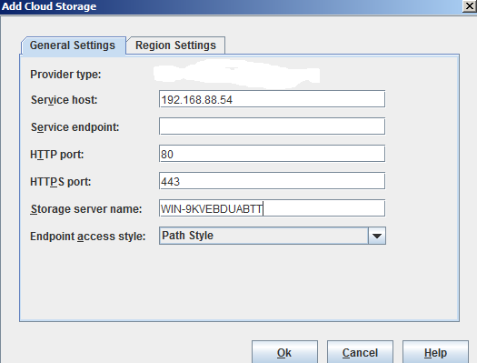

1. Back on the Cloud Storage Provider page complete the following fields:

* Select the **Service host** and **Storage server name** that you just created
* Choose a NetBackup **Media server name.**
* You will be adding this storage server to additional media servers later.
* Enter your SES S3 Pool user's username in Base64-encoded format into the **Access** **key ID** field. This should from the SES S3 user that you created...
* Enter your SES S3 Pool user's password in MD5-hashed format into the **Secret** **access key** field. This should from the SES S3 user that you created.

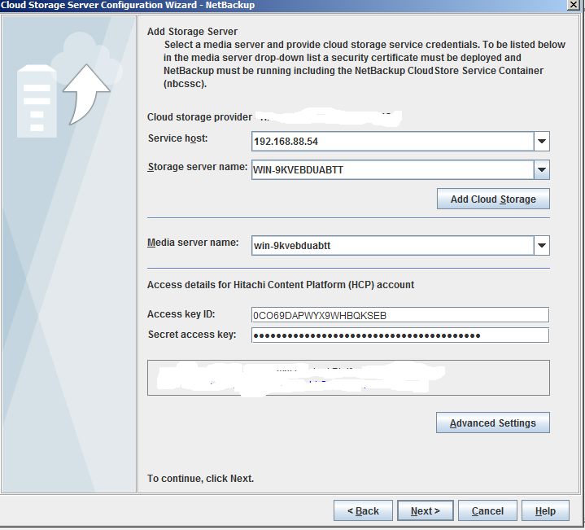

Click the **Advanced Settings** button

1. In the **Advanced Server Configuration** dialog: a. **Use SSL** is checked by default.
   * 1. Leave the checkbox checked if you are connecting to SUSE Enterprise Storage and you have installed a certificate signed by a trusted certificate authority on the SES.
     2. Uncheck the checkbox if:
        1. You are connecting to SUSE Enterprise Storage and your SES is using the self-signed certificate generated by the SES system.
2. **Use Proxy Server** is unchecked by default.

I. Check this checkbox only if you require a proxy to connect with SES.

1. Click **OK** to continue.

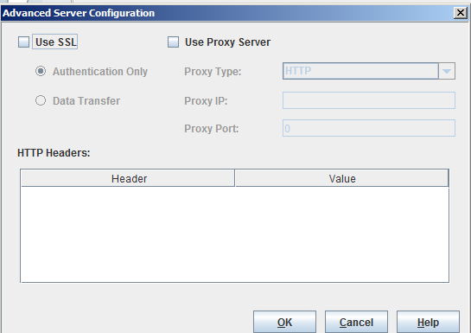

1. Back in the wizard click the Next button to proceed to the encryption setting page of the Cloud Storage Server Configuration Wizard.
2. By default, Encryption is disabled.
   1. Check this box only if you want to encrypt data before sending it to SES. You may wish to use encryption when SSL is disabled in the Advanced Server Configuration.
   2. If you check the box, configure your Key Management Server properties.

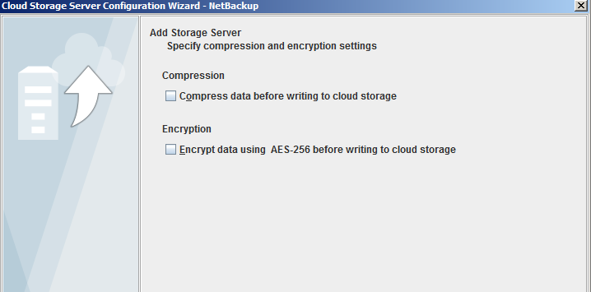

1. The Cloud Storage Server Configuration Summary will be listed. Verify that settings are correct and click **Next**.

Configure a Disk Pool

To define a disk pool, using the Disk Pool Configuration Wizard.

On the first page of the Disk Pool Wizard (DPW) you are prompted to select a storage server volume to add to the disk pool. The list of available volumes should be empty. Click the **Add New** **Volume** button

1. 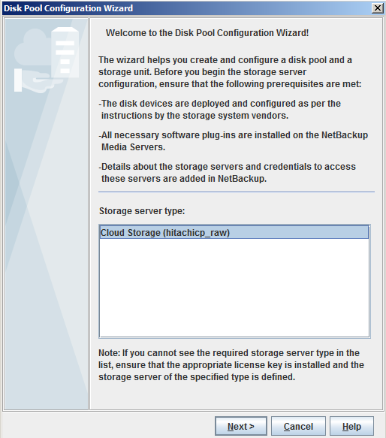Once the Cloud Storage Server is configured, go to Disk Pools on the right hand side of the navigation tree. Select the Disk Pool name and Create New Disk Pool. Select Next to start create a new Volume.
2. At the next screen, select Add New Volume. Enter a name under Bucket Name field and click on Add. This will create a new Volume for use in NBU.

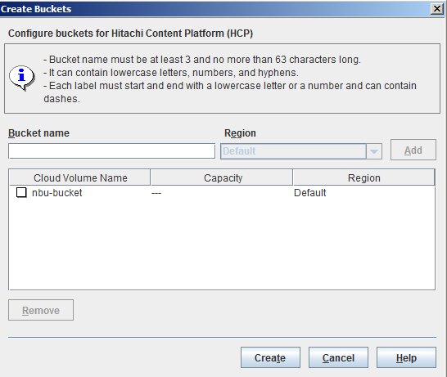

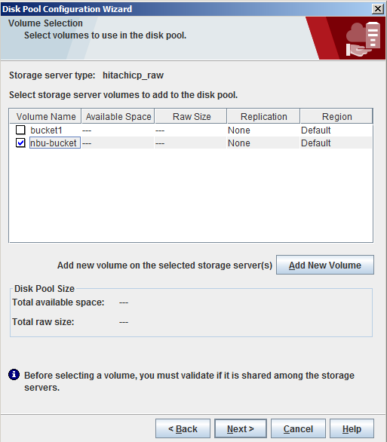

1. At the final stage, give a Disk pool name and select next finish with Disk pool creation

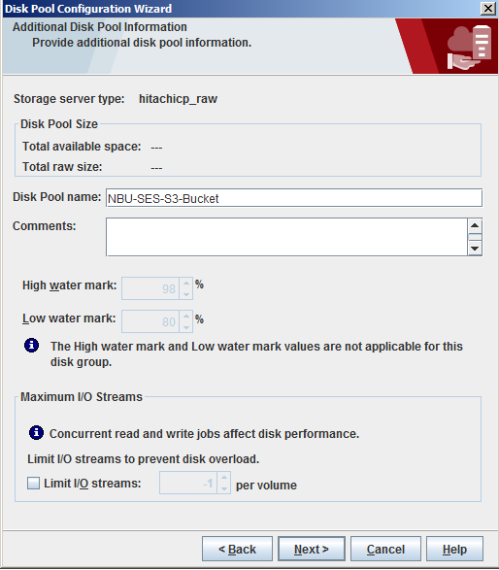

Configure Policies

In order for objects to be backed up from NetBackup to SUSE Enterprise Storage, create a policy by following the steps below.

1. Using the NetBackup Administration Console, select Master Server on the upper left pane and choose **Create Policy**.

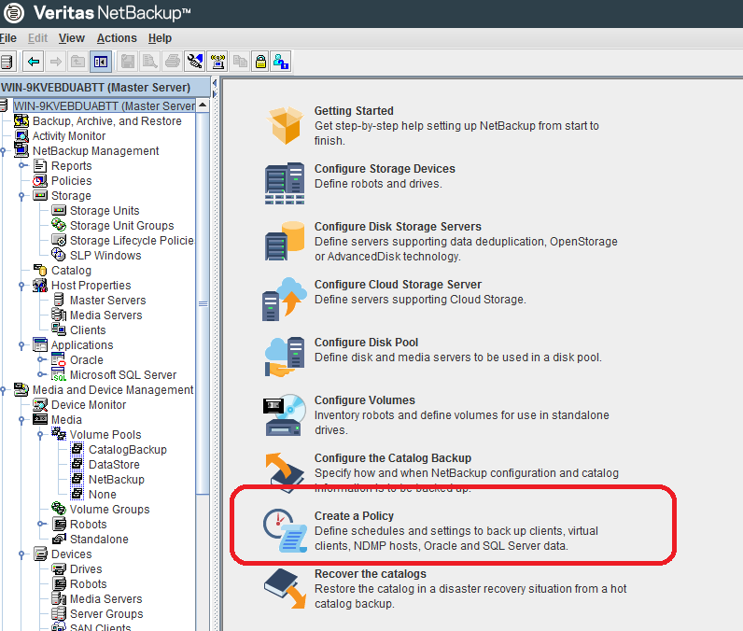

1. For this setup, select **File systems, databases, applications**, and click **Next**.

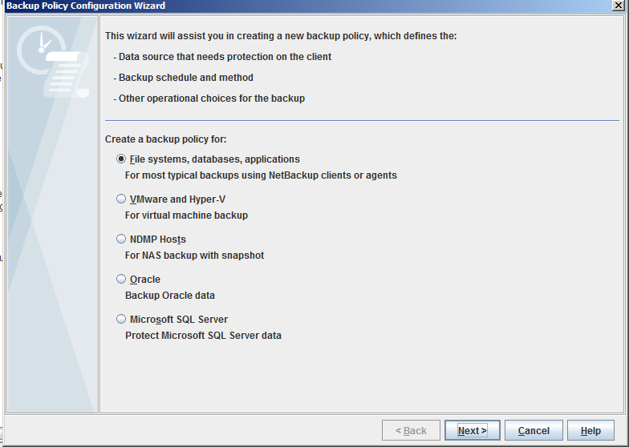

1. Provide a policy name and select the policy type.

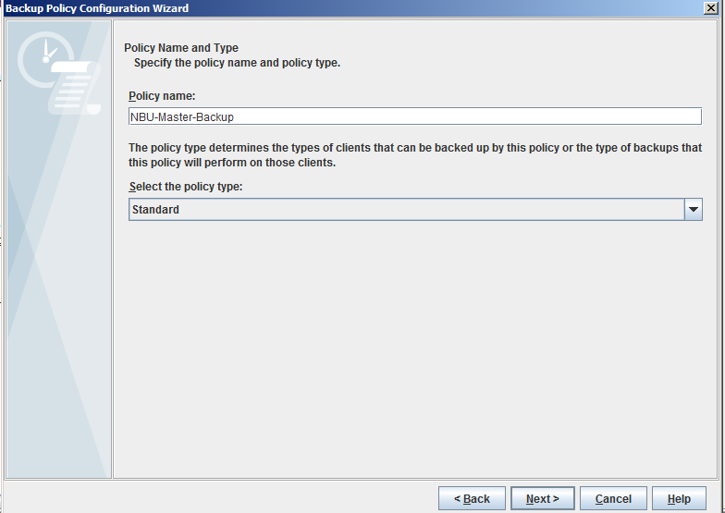

1. Click **Add** and select client(s) that will cover this backup policy.

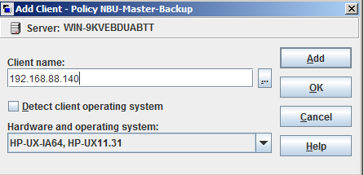

1. Clients successfully added will be listed and include the type of hardware and operating system.

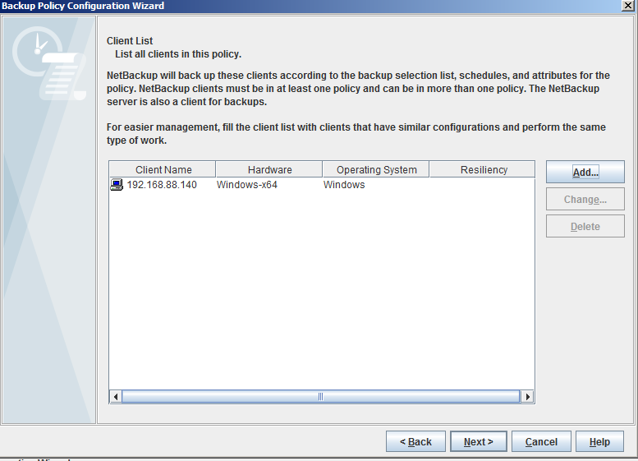

1. Define the location of data to back up. Click **Add** and specify the directory or files to back up. You can add multiple locations if needed.

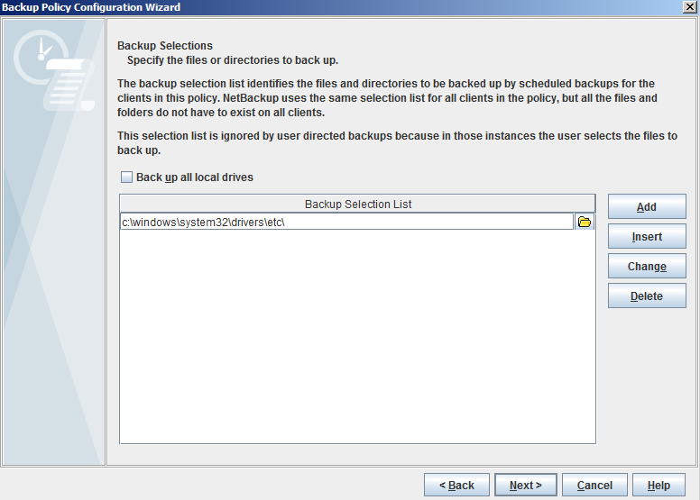

1. Select the backup type for this policy

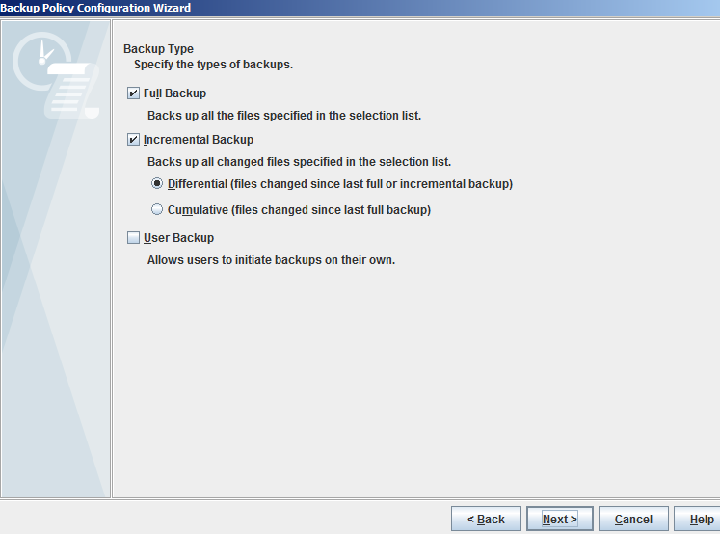

1. Define the frequency of the backup.

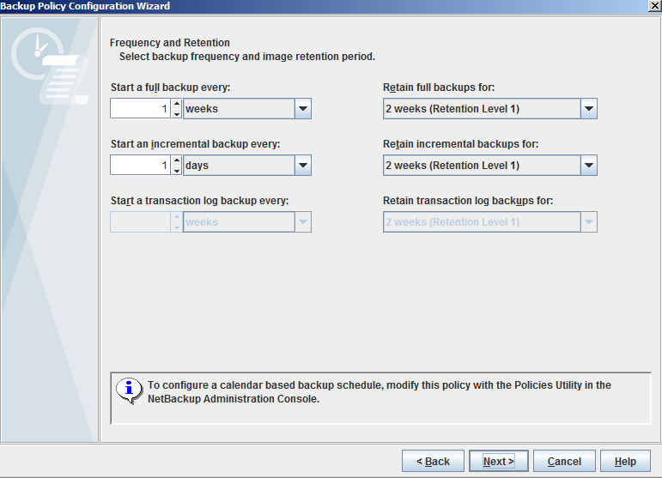

1. Specify a schedule backup window, in this case all day for 7 days a week.

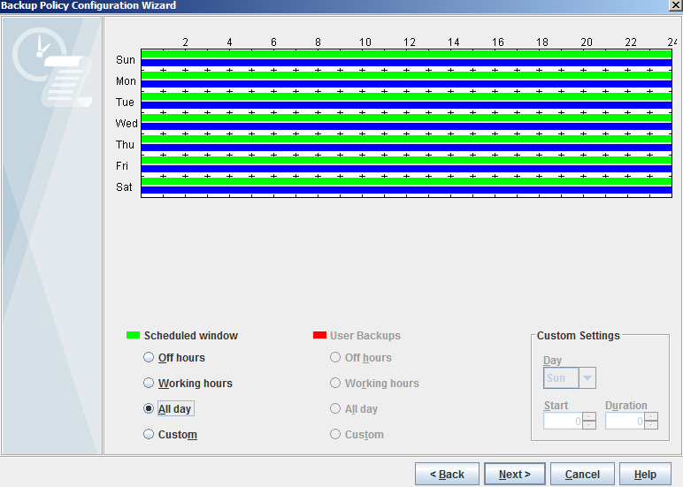

1. Once all settings have been defined, click **Finish** to complete.

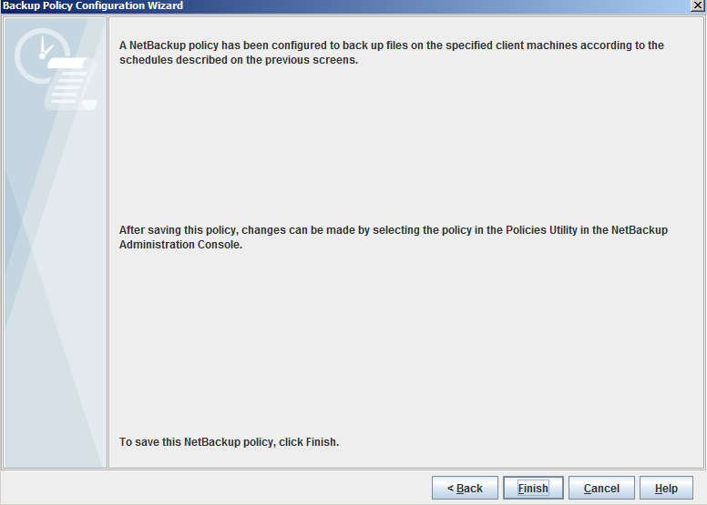

1. Newly created policies will be listed in the All Policies list within the NetBackup Master Server.

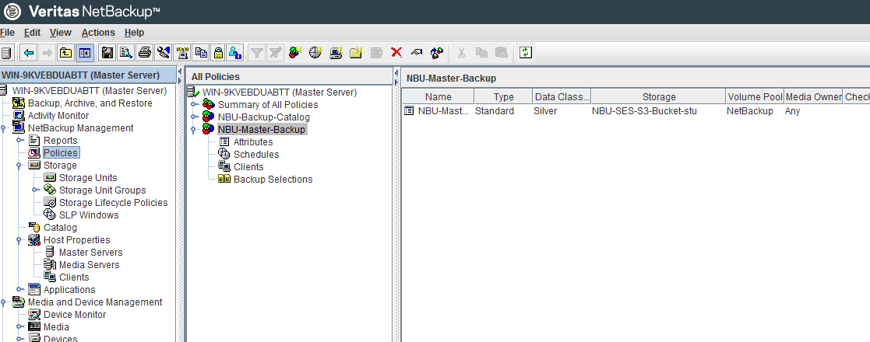

1. Ensure that the Backup Policy Point to the correct Storage STU. Click on the Backup policy, and ensure that the policy storage is the one that is created previously

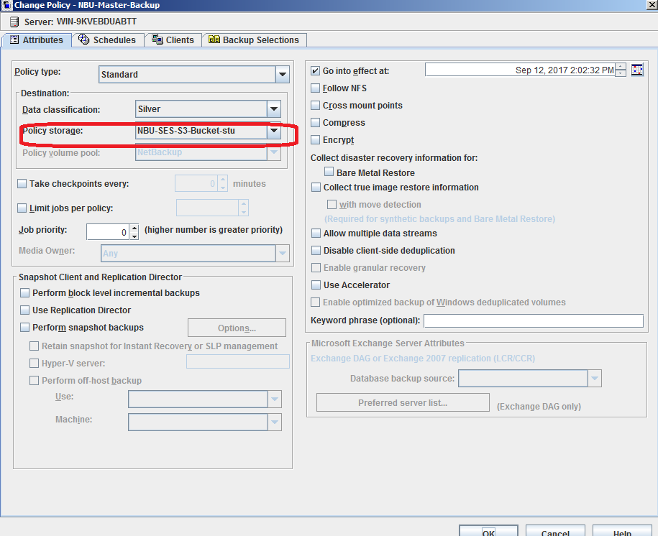

1. Manual backup the policy

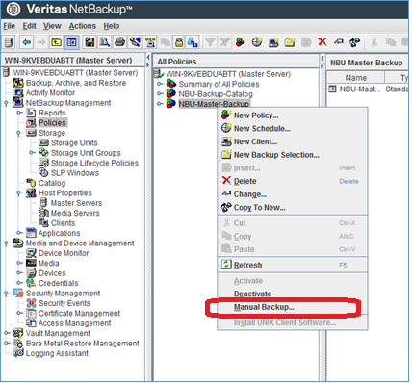

1. Monitor the completion of backup job from the activity screen

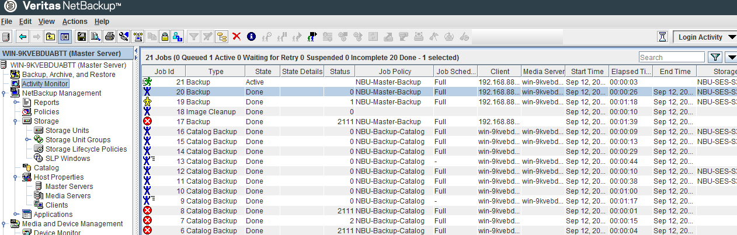

**Verification of data written to SES**

At this point of writing, the fastest way to verify backup is written to the SES is to check on the Openattic interface on SES version 5.

Once logged into Openattic, go to **Pools** and select the pool **default-rgw.bucket.data**. Below the screen, click on **Statistics** follow by the **Pool:default.rgw.buckets.data**

Here you will be able to view the amount of data being written to the bucket/pool that you have defined during setting up of NBU disk volume. Notice the capacity as more data are written to the SES.

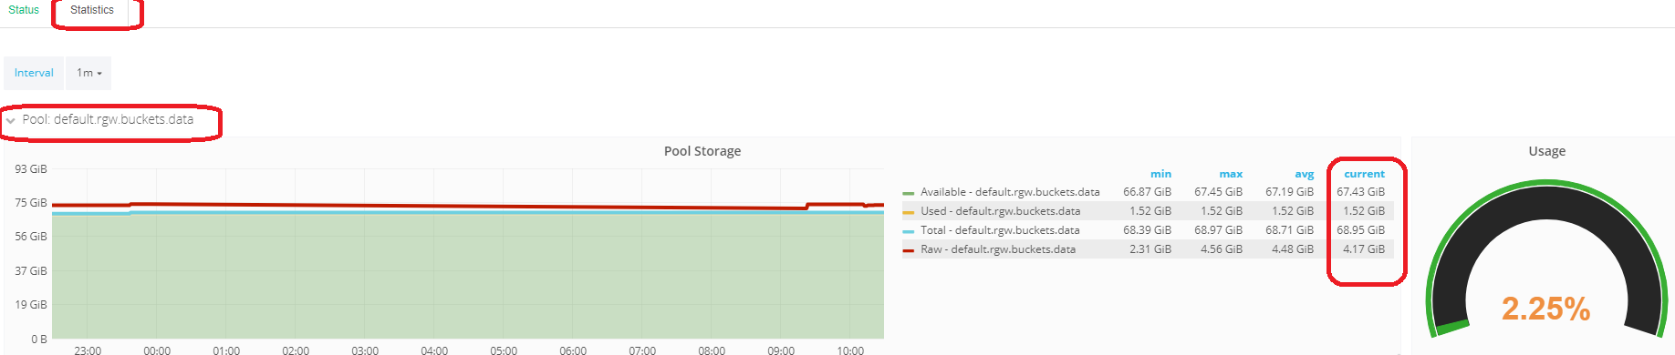

**Conclusion**

Continued data growth is putting a strain on tradition backup solutions in the data center. Enterprises are looking for solutions that scale, can operate remotely using cloud native protocols, and provide a cost effective, yet performance solution. SUSE Enterprise Storage (SES) satisfies these needs as a disk to disk storage option for VERITAS NetBackup.

**References**

The following documents can be found on the SUSE and VERITAS website:

SUSE Administration Guide[2]2

VERITAS Administrator Guide

1. 1 https://www.suse.com/documentation/suse-enterprise-storage-5/book_storage_deployment/data/book_storage_deployment.html
2. 2 https://www.suse.com/documentation/suse-enterprise-storage-5/book_storage_admin/data/book_storage_admin.html